Contract
Delivery van
1. General
BETWEEN
….…............................................................................................................................ (kring/association)
represented by:

Contact person (if this is not the driver)
Name:………………………………………………………………………………………………………………
Function:……………………………………………………………………………………………………………
Email: ……….………………………………………………………………………………………………………
Phone number: ……….…………………………………………………………………………………….……
The contact person is responsible for passing on the provisions below to the driver.

Driver
Name:………………………………………………………………………………………………………………
Function:……………………………………………………………………………………………………………
Email: ……….………………………………………………………………………………………………………
Phone number: ……….…………………………………………………………………………………….……
Student number: ………….……………………………………………………………………………………
hereinafter referred to as the borrower,
AND
DIDO vzw, with a registered office at 3000 Leuven, 's Meiersstraat 5, hereinafter referred to as LOKO.

Date and time of pick-up of van……… / / at (hour) …..
At Central Logistics Services KU Leuven
ate and time of return of van……… / / at (hour) …….
At Central Logistics Services KU Leuven/Central Dispatch (delete what does not fit)

Reason for transport: …………………………………………………………………………………………….
2. PROVISIONS CONCERNING THE USE OF THE VAN
KU Leuven's Central Logistics Services (hereafter CLD) puts a KU Leuven service vehicle at the disposal of ‘kringen’ and recognised free associations through LOKO. The service vehicle is borrowed only from ‘kringen’ and free associations recognised by LOKO (see https://www.loko.be/verenigingen).
The van may only be used for activities within the Leuven region. The van should ideally be used to transport materials not from KU Leuven's lending service. Exceptions may be requested to use the van outside Leuven. These may or may not be approved.
2.1 VEHICLE RESERVATION
The ‘kring’ or association can reserve the vehicle from the LOKO central staff officer, contactable at loko@loko.be. This is done at least one week in advance. The central staff checks with the CLD of KU Leuven whether the vehicle is available. Recurring requests can be made, such as every first Monday of the month. The vehicle must be picked up between 8am and 4.30pm at the KU Leuven CLD.

When reserving the vehicle at LOKO, the following information is stated via mail:
- the driver's name and student number
- the ‘kring’ or association
- reason for transport
- concrete time of pick-up and return

If the vehicle is available, the ‘kring’/association will sign this contract in advance and pay a deposit of 500 euros (possibly arranged through the fixed deposit system of the LOKO lending service). If a ‘kirng’ or free association has a fixed deposit, this can serve as a deposit for the van.
2.2 PICK-UP OF THE SERVICE VEHICLE
- The vehicle is always located in front of the "Central Warehouse" building in Heverlee (see plan) and should also be placed back there afterwards.
- Drivers must identify themselves using their student card. The student card is also needed when starting the car.
- The vehicle key can be collected and returned at CLD (see plan) between 8am and 4.30pm. Outside these hours, the key can be returned to Central Dispatch (CD, see plan).
- When picking up the key, the CLD will ask you to fill in another contract that includes details of the driver's driving licence.

2.3 FUEL
The fuel tank will be filled for at least ⅓ and should also be returned that way. CLD will provide a fuel card when picking up the key that can be used to fill up the vehicle (driver card = “bestuurder”). Inside the vehicle itself, a second card is inserted in the sun visor (vehicle card = “voertuig”). Both cards are needed to refuel.
At certain gas stations, you can refuel with the fuel cards at a discount:
- Esso, Texaco, Maes, Octa+, Shell
At other gas stations (Lukoil, Q8, G&V, Gabriëls) you refuel without a discount at the regular pump price.
The cost of the kilometers driven will be charged to LOKO on a monthly basis. LOKO will pass these costs on to the users by deducting these costs from the deposit/invoicing if the costs exceed the deposit.

Procedure to refuel:
- Insert driver card (“bestuurder”) into payment terminal
- Take backdriver card
- Select language
- Select fuel
- Enter pump number
- Enter PIN code
↓
- Insert vehicle card (“voertuig”) into payment terminal
- Take back vehicle card
- Replacement vehicle yes/no
- If no, enter mileage
- You can refuel.
2.4 MANUALS AND ON-BOARD DOCUMENTS
There will be a folder in the glove compartment with all official board documents and necessary phone numbers.
2.5 RESPONSIBILITY OF DRIVER AND/OR BORROWER (NO MORE THAN 2 DIFFERENT PERSONS)
- The driver reports in possession of his student card and is responsible for the vehicle's order and cleanliness. The vehicle should be returned in the condition in which it was received.
- The driver is partly responsible for ensuring that the goods are properly loaded (see general regulations 2.8).
- All costs resulting from damage and/or decommissioning of the service vehicle identified by our services during the period of borrowing shall be borne entirely by the borrower.
- In case of damage to the vehicle (damage caused by yourself or damage caused by third parties) and accident, a collision form must always be filled in correctly by the driver and remitted to CLD immediately.
- All costs associated with traffic violations are the responsibility of the driver. The driver of the vehicle must therefore pay all fines themselves. As soon as CLD receives documents relating to traffic violations, they will be sent to the known student association and a copy to LOKO. Upon receipt of a reply form, the driver will have to fill in box B in case of traffic offenses and immediately return this form to CLD. If CLD has not received the form back within 2 working days, CLD will proceed to fill the form unilaterally and remit it to the police department concerned.
- The driver should always report damage (or suspicion that there might be damage somewhere) to LOKO and CLD!
- In case of problems, the driver calls the CLD during opening hours (8am-4.30pm) or the KU Leuven Central Dispatch outside opening hours (016 32 20 00)

2.6 MANAGEMENT OF THE SERVICE VEHICLE
- CLD is responsible for the official equipment of the vehicle and official on-board documents.
- CLD is responsible for maintenance, repairs and technical inspection of the vehicle.
- If necessary, tension cables can be requested from the CLD.

2.7 INSURANCE
Students renting the vehicle are insured as follows:
- Damage caused to third parties with the vehicle is covered through the vehicle's BA insurance. Internal damage (e.g. to the KU Leuven) is not covered.
- Bodily injuries to the passengers (not the driver) are covered through the vehicle's third-party insurance.
- Bodily injuries to the student driver are covered through the student accident insurance if the student uses the vehicle in relation to their studies, i.e. not for private activities or student association activities.
  - If third parties are liable, the student-driver's injuries are covered by the other party's insurance. The student-driver's personal insurance may intervene for physical injuries to the student-driver themself.
- Damage to the vehicle is not covered. It is possible that the damage will be claimed from the student by CLD.
  - The current vehicle, given its age, does not have omni-insurance.
The CLD and LOKO provide this van for free (only the costs of fuel are paid by the user), but be aware that the van is mostly free because it is not insured for damage. There is a big risk and thus responsibility required from the user and driver(s). Be sure to really consider this before you lend the van.
2.8 FAILURE TO COMPLY WITH THE ESTABLISHED PROCEDURE
Any breach of this procedure will result in consequences for the student association concerned.
This will start with a warning, but after consistent errors may range from monetary fines to exclusion from use of the van. For example, if damage is not properly reported, or if the loading fuse is not in order, such penalties may follow.

Contact info CLD Contact info CD
Centrale Logistieke Diensten Centrale Dispatch
W. de Croylaan 36 bus 5575, 3001 Heverlee W. de Croylaan 40 bus 5571, 3001 Heverlee
Tel: +32 16 32 23 23 Tel: +32 16 32 20 00
Mail: cld@kuleuven.be Mail: cd@kuleuven.be
pen every weekday from 8 am to 4.30 pm Permanence 24/7
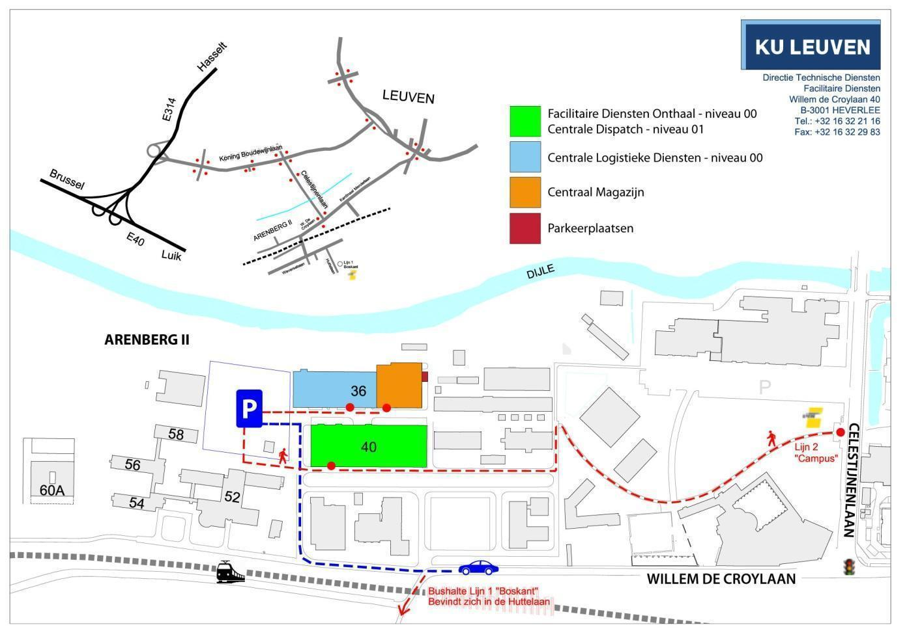

  - GENERAL LOADING REQUIREMENTS
- The load of a vehicle must be suitable such that under normal road conditions:
  - the driver's visibility is not obstructed;
  - cannot present a danger to the driver, the persons transported and other road users;
  - no damage can be caused to the public road, its appurtenances, to the works of art in it or to public or private property;
  - the load cannot drag or fall on the public road;
  - the stability of the vehicle cannot be affected;
  - the lights, reflectors and registration number do not become invisible.
- Anything that serves to secure or shelter the load must be in good condition and used correctly. Any component enclosing the load, such as a chain, tarpaulin, net, etc., must closely enclose the load.
- The driver of the vehicle must take the necessary measures to ensure that the load, as well as anything that serves to secure or shelter the load, would not by noise hinder the driver, cause discomfort to the public or frighten animals.
- No long items may be transported that project beyond the perimeter of the vehicle or require the side or rear doors to remain open.
According to the classification of traffic offences (KB 26/04/2004), offences where the rules concerning cargo are not observed are classified as a serious offence of the second degree. This means: driving licence may be revoked - immediate collection of €175 - order for payment of €175 - court of €275 to €2750.

Digitally formatted on in which each party signs it (digitally).

SIGNATURE ‘KRING’/ASSOCIATION SIGNATURE LOKO
Name:

's Meiersstraat 5 - 3000 Leuven
tel.: 016/90 55 20
loko@loko.be
www.loko.be

